**MODEL FOR PLANT DISEASE PREDICTION:**

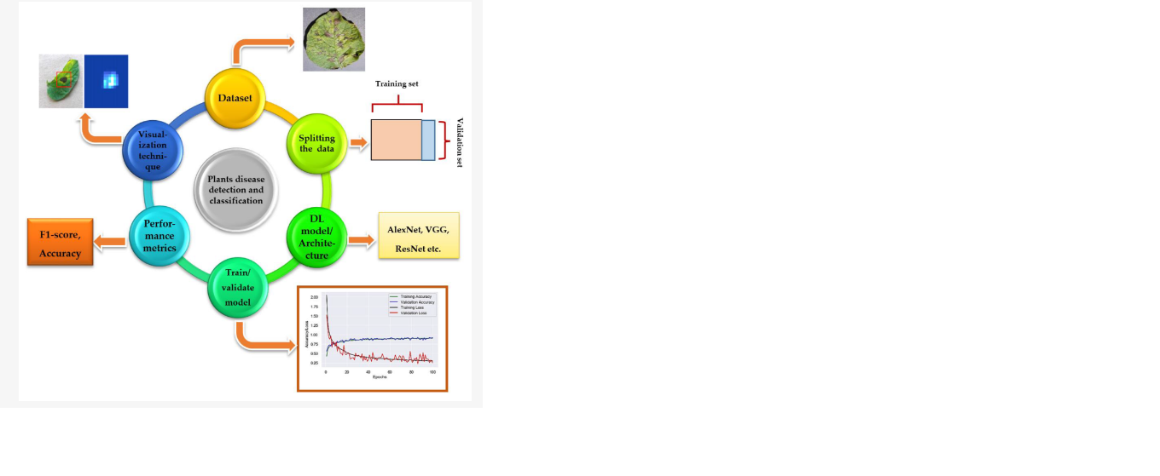The dataset is collected then split into two parts, normally into 80% of training and 20% of validation set. After that, DL models are trained from scratch or by using transfer learning technique, and their training/validation plots are obtained to indicate the significance of the models.